Array Question Using Algorithm
- Finding the largest number of an array:
Input:
#include <iostream>
#include <math.h>
using namespace std;
int main()
{

int array[] = { 1,2,6,3,8,9,15,19,7,51,92,27,10 };
int largest = array[0];

for (int i = 0; i < sizeof(array) / sizeof(int); i++)
{
if (array[i]>largest) {
largest = array[i];

}

}
cout << largest << " ";
}
Output:
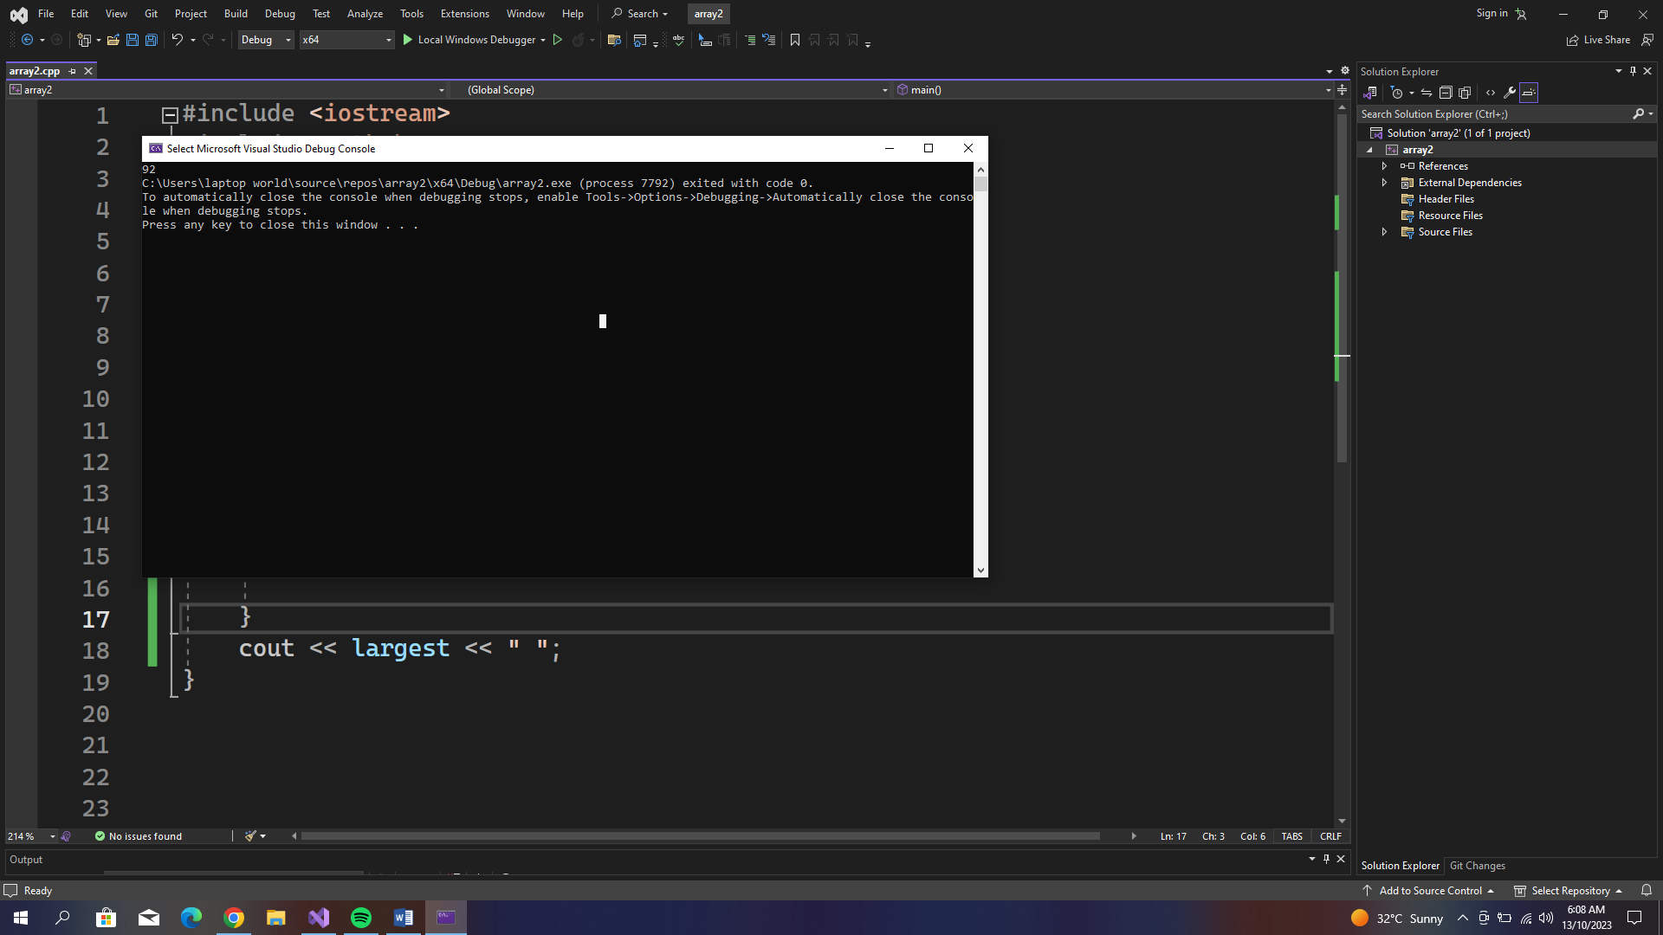

- Finding the largest three number of an array:
Input:
#include <iostream>
#include <math.h>
using namespace std;
int main()
{

int array[] = { 1,2,6,3,8,9,15,19,7,51,92,27,10 };
int largest = array[0];
int Slargest = array[0];
int Tlargest = array[0];

for (int i = 0; i < sizeof(array) / sizeof(int); i++)
{
if (array[i]>largest) {
largest = array[i];
}

}
for (int i = 0; i < sizeof(array) / sizeof(int); i++)
{
if (array[i] < largest && array[i]>Slargest) {
Slargest = array[i];
}
}
for (int i = 0; i < sizeof(array) / sizeof(int); i++)
{
if (array[i] < Slargest && array[i]>Tlargest) {
Tlargest = array[i];
}
}
cout << largest << " ";
cout << Slargest << " ";
cout << Tlargest << " ";
}

Output:
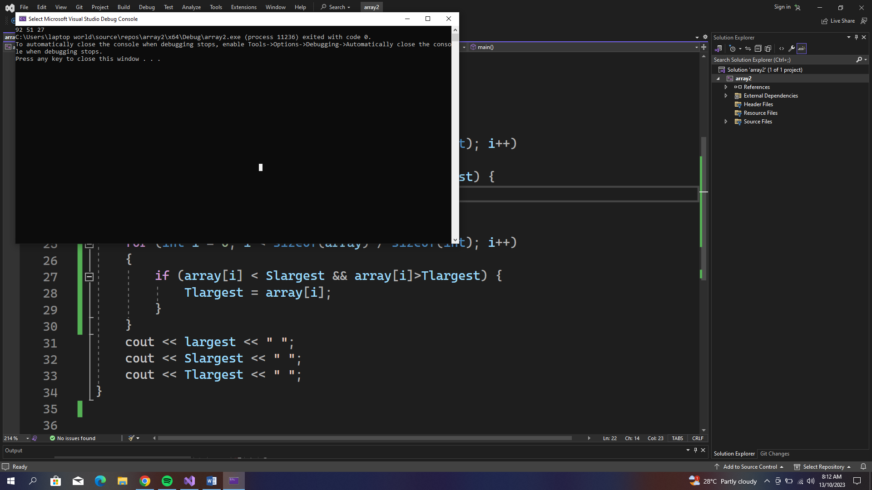

- Finding the largest three number of an array:
Input:
#include <iostream>
#include <math.h>
using namespace std;
int main()
{

int array[] = { 1,2,6,3,8,9,15,19,7,51,92,27,10 };
int largest = array[0];
int Slargest = array[0];

for (int i = 0; i < sizeof(array) / sizeof(int); i++)
{
if (array[i]>largest) {
largest = array[i];
}
}
for (int i = 0; i < sizeof(array) / sizeof(int); i++)
{
if (array[i] < largest && array[i]>Slargest) {
Slargest = array[i];
}
}
cout <<"Second Largest element : " << Slargest << " ";
}

Output:

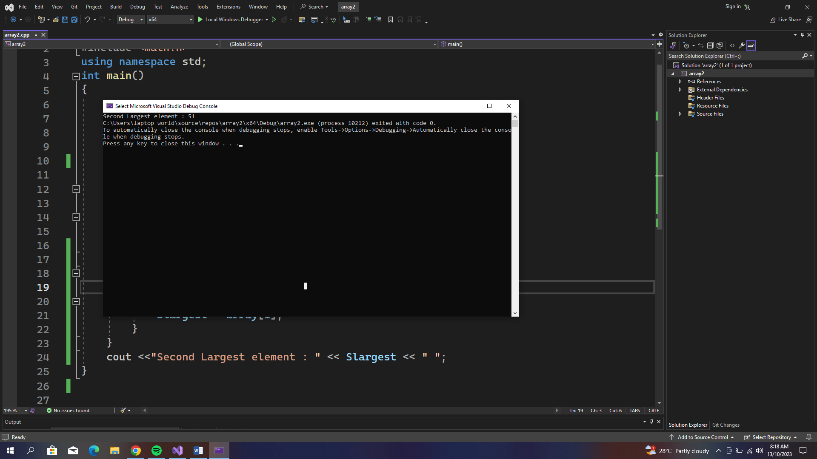

4. Write a C++ program to find the second smallest elements in a given array of integers.
Input:
#include <iostream>
#include <math.h>
using namespace std;
int main()
{

int array[] = { 1,2,6,3,8,9,15,19,7,51,92,27,10 };
//sorting an array first in ascending order
for (int i = 0; i < sizeof(array) / sizeof(int); i++) {
for (int j = i+1; j < sizeof(array) / sizeof(int); j++) {
if (array[i]>array[j]) {
int temp = array[i];
array[i] = array[j];
array[j] = temp;

}
}
}
cout <<"The Second smallest element : "<< array[1];
}
Output:

